29.70: 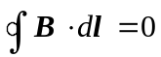 (no currents in the region). Using the figure, let 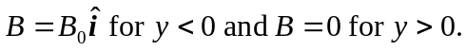

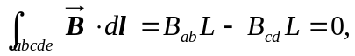

but 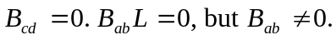 This is a contradiction and violates Ampere’s Law. See the figure on the next page.

